Software Architecture of a Smart Medication Management and Vital Signs Monitoring System
1. System Overview
The suggested Smart Medbox Alert System utilizes a decentralized, three-tier Internet of Things (IoT) architecture, consisting of an Edge Node (ESP32 microcontroller), a Cloud Infrastructure (Google Firebase), and a Client Application (Android native application). This topology guarantees elevated fault tolerance, asynchronous communication, and real-time synchronization. The software design is divided into four main subsystems: Optical Character Recognition (OCR) for prescription analysis, high-frequency biometric sensor synchronization, autonomous scheduling, and inventory management.
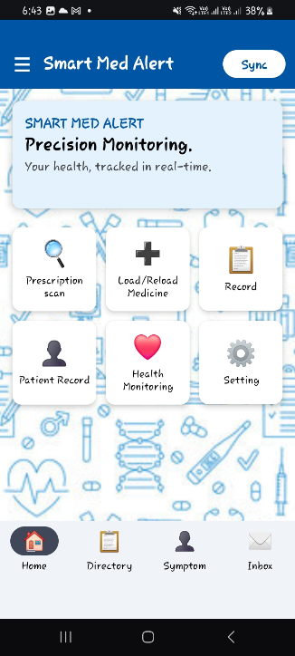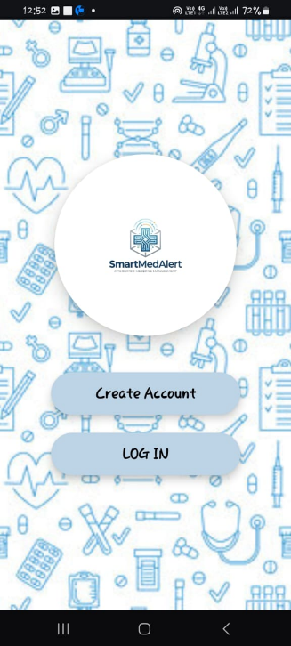

2. Machine Learning (ML) Prescription Extraction Subsystem
The client application incorporates a machine-learning-driven prescription extraction workflow utilizing Google ML Kit to eradicate manual data entry errors. This subsystem's architecture functions in three consecutive stages:
i) Image Processing and OCR: The program collects a prescription image using the device camera or gallery and transforms it into an InputImage object. The ML Kit Text Recognition API analyzes the image to retrieve unprocessed text segments and their corresponding bounding box coordinates.
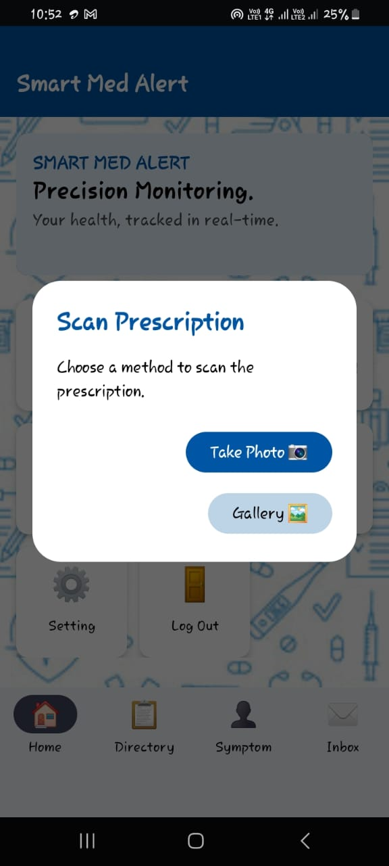
ii) Spatial Sensoring: A bespoke spatial sorting algorithm arranges unstructured text lines according to their vertical (Y-axis) and horizontal (X-axis) boundary coordinates, thereby reproducing the tabular format of conventional medical prescriptions.
iii) Fuzzy Parsing and dictionary matching: The program use Regular Expressions (Regex) to detect numerical dosages (e.g., "500mg"), length (e.g., "5 days"), and ingestion time indicators (e.g., "1+0+1"). To precisely ascertain the medication name despite handwriting discrepancies or OCR inaccuracies, the system calculates the Levenshtein distance between the extracted string and a local JSON-based medical lexicon. If the distance is within an acceptable range, the medication name is standardized and securely transmitted to Cloud Firestore.
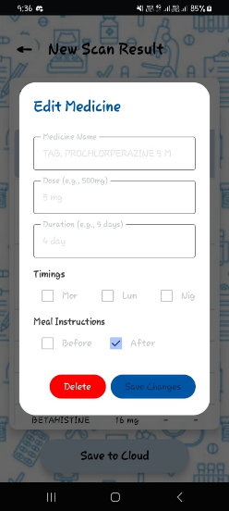
3. Real-Time Synchronization of Hardware and Sensors
The system utilizes a MAX30102 photoplethysmography (PPG) sensor to measure Heart Rate (HR) and Blood Oxygen Saturation (SpO2). Processing this raw optical data demands precise timing, requiring a dual-core software design on the ESP32 utilizing FreeRTOS.
i) Core 1 (Biometric Processing): A specialized FreeRTOS activity executes the PPG algorithm at a sample frequency of 400Hz. It employs a continuous sliding window mechanism and a software-based moving average filter (size=5) to mitigate high-frequency motion artifacts. An adaptive infrared (IR) threshold (IR < 15,000) effectively governs a "Idle State," purging extraneous data immediately upon finger removal.
ii) Core 0 (Cloud Sync): The second core manages Wi-Fi connectivity, retrieves Network Time Protocol (NTP), and ensures SSL encryption for Firebase.
Upon the detection of valid HR and SpO2 data on Core 1, Core 0 promptly transmits an HTTPS PATCH request to the Firestore database. In contrast, the Android application employs Firestore's addSnapshotListener, creating a persistent WebSocket connection that refreshes the mobile User Interface (UI) in real-time without the need for manual polling.
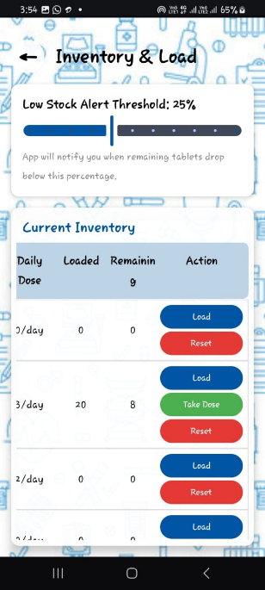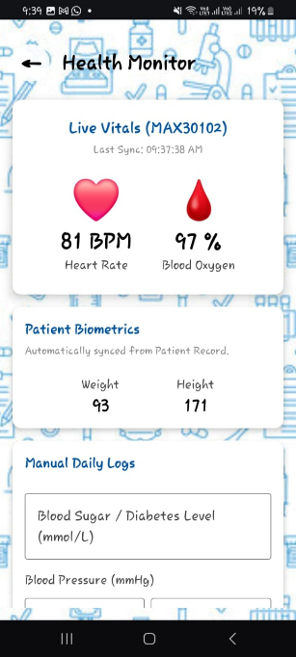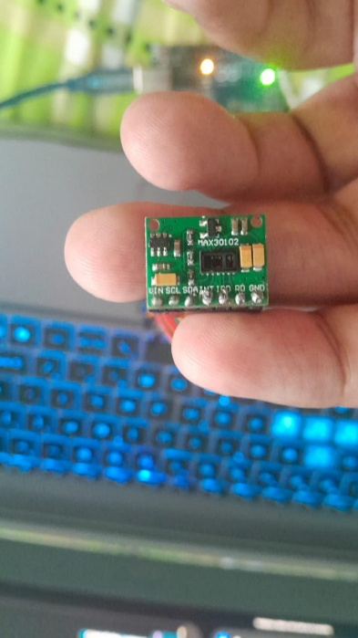

4. Autonomous Scheduling and Alarm System
A prevalent failure point in mobile-dependent IoT systems is the latency induced by smartphone energy conservation strategies (e.g., Android Doze Mode). The architecture separates the physical hardware alarms from the mobile operating system to address this issue. Upon defining a prescription schedule, the Android application securely stores the TargetTime in the cloud. Upon initialization, the ESP32 retrieves the universal atomic time from an NTP server (synchronized to UTC+6). The microcontroller continuously compares its internal hardware clock with the cloud-specified TargetTime. When the times coincide, the ESP32 autonomously activates the physical LED and buzzer alarms. The Android application employs AlarmManager with setExactAndAllowWhileIdle to deliver a local OS-level notice to the user's device. To guarantee patient safety, the edge firmware has a "Overdose Protection" protocol; if a user neglects a dose and a subsequent alarm activates, the ESP32 autonomously clears the previous missed alarm from both the physical pins and the cloud database, guaranteeing that only the most recent dose remains active.
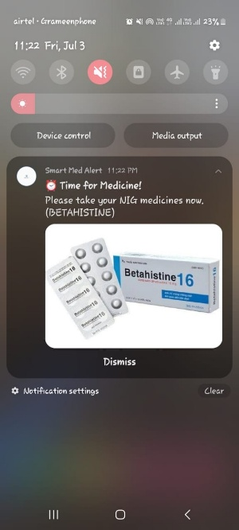

5. Inventory Oversight and Low-Stock Notification
The solution upholds a cloud-based ledger of pharmaceutical inventory, juxtaposing tabletsLoaded with remainingTablets. The deduction architecture is activated by hardware: when the patient physically engages with the medbox to ingest a pill, a magnetic reed switch transmits a LOW signal to the ESP32. The ESP32 records the exact NTP timestamp and reduces the currentTakenCount in Firebase. The Android client monitors these hardware state alterations. Upon detecting a switch trigger, the application cross-references the consumed slot (Morning, Lunch, or Night) with the user's prescription matrix, algorithmically determining the specific pill count. The application perpetually computes the residual proportion of the total inventory loaded. When the remaining tablets fall below a user-specified level (e.g., 25%), the application activates an immediate Low Stock Alert through the Android NotificationManager, urging the user to replenish the physical box.
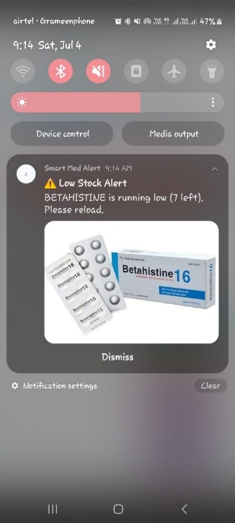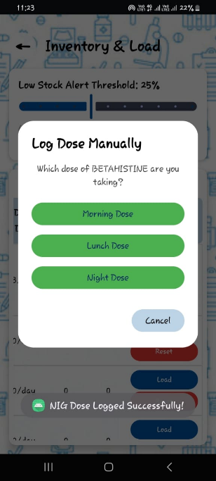
6. Monitoring of Medication Compliance (Record Section)
The architecture features a dynamic History module that persistently records precise drug consumption events to monitor patient compliance. This solution, unlike conventional programs that depend solely on manual user input, captures the exact Network Time Protocol (NTP) timestamp at the instant the physical ESP32 pillbox is opened. The Android client acquires this data using real-time Firestore listeners, classifying daily doses into specific visual states: 'Taken', 'Pending', or 'Missed'. This detailed, hardware-based tracking system significantly minimizes self-reporting bias, offering a precise and unalterable record of the patient's daily medication adherence at morning, lunch, and evening intervals.
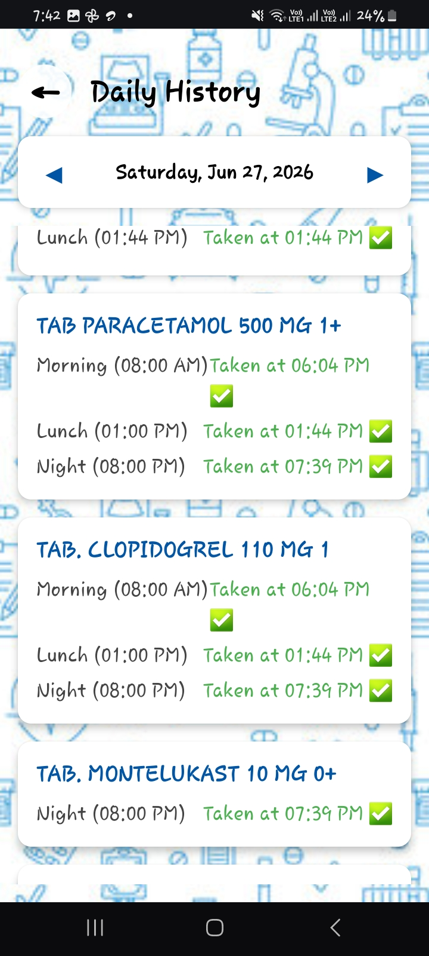
7. Data Consolidation and Report Exportation
The application has a comprehensive data export subsystem to connect automated IoT tracking with clinical evaluation. Users may choose specific date ranges (e.g., 7 days, 30 days, or bespoke intervals) to produce detailed, offline-accessible CSV (Comma-Separated Values) reports. The backend export algorithm methodically consolidates data from three separate Firestore collections: static patient biometrics, active prescription matrix, and timestamped adherence records. By integrating this complex data into a unified, standardized spreadsheet, the system provides healthcare professionals with practical, objective insights on the patient's long-term adherence patterns, enabling data-driven medical interventions.
